**Project Planning Phase**

**Project Planning Template (Product Backlog, Sprint Planning, Stories, Story points)**

|  |  |
| --- | --- |
| Date | 18 October 2022 |
| Team ID | PNT2022TMID08664 |
| Project Name | Project – Early Detection of Chronic Kidney Disease using Machine Learning |
| Maximum Marks | 8 Marks |

**Product Backlog, Sprint Schedule, and Estimation (4 Marks)**

Use the below template to create product backlog and sprint schedule

|  |  |  |  |  |  |  |
| --- | --- | --- | --- | --- | --- | --- |
| **Sprint** | **Functional**  **Requirement (Epic)** | **User Story**  **Number** | **User Story / Task** | **Story Points** | **Priority** | **Team**  **Members** |
| Sprint-1 | Collection of Dataset | USN-1 | I need to collect dataset from IBM resource | 3 | High | Santhosh Kumar  Nishanth Bhoopathy  Nimalan  Gowtham |
| Sprint-1 | Data Pre-Processing | USN-2 | I need to take raw data and transform it into a format that can be understood and analysed by machine learning algorithms | 6 | High | Santhosh Kumar  Nishanth Bhoopathy  Nimalan  Gowtham |
| Sprint-2 | Exploratory Data Analysis (EDA) | USN-3 | I need to do Exploratory Data Analysis to obtain the main characteristics | 8 | Medium | Santhosh Kumar  Nishanth Bhoopathy  Nimalan  Gowtham |
| Sprint-2 | Model Building | USN-4 | I need to explore the type of algorithms which can be used to train and test the model for providing the best accurate results | 13 | High | Santhosh Kumar  Nishanth Bhoopathy  Nimalan  Gowtham |
| **Sprint** | **Functional**  **Requirement (Epic)** | **User Story**  **Number** | **User Story / Task** | **Story Points** | **Priority** |  |
| Sprint-3 | UI Designing | USN-5 | As a developer, I need to design a simple and understandable UI | 3 | Medium | Santhosh Kumar  Nishanth Bhoopathy  Nimalan  Gowtham |
| Sprint-3 | Authentication | USN-6 | As a developer, I need to add authentication to ensure trusted user access the application | 4 | High | Santhosh Kumar  Nishanth Bhoopathy  Nimalan  Gowtham |
| Sprint-4 | UI Integration | USN-7 | As a developer, I need to integrate the user interface and the model developed using machine learning algorithms | 5 | Medium | Santhosh Kumar  Nishanth Bhoopathy  Nimalan  Gowtham |
| Sprint-4 | Dashboard | USN-8 | As a user, I will be able to enter my test results as input which will be used for prediction | 5 | High | Santhosh Kumar  Nishanth Bhoopathy  Nimalan  Gowtham |
| Sprint-4 | Result | USN-9 | As a user, I will receive whether chronic kidney disease is there or not | 5 | High | Santhosh Kumar  Nishanth Bhoopathy  Nimalan  Gowtham |

**Project Tracker, Velocity & Burndown Chart: (4 Marks)**

|  |  |  |  |  |  |  |
| --- | --- | --- | --- | --- | --- | --- |
| **Sprint** | **Total Story Points** | **Duration** | **Sprint Start Date** | **Sprint End Date (Planned)** | **Story Points**  **Completed (as on**  **Planned End Date)** | **Sprint Release Date (Actual)** |
| Sprint-1 | 9 | 6 Days | 24 Oct 2022 | 29 Oct 2022 | 9 | 31 Oct 2022 |
| Sprint-2 | 21 | 6 Days | 31 Oct 2022 | 05 Nov 2022 |  |  |
| Sprint-3 | 7 | 6 Days | 07 Nov 2022 | 12 Nov 2022 |  |  |
| Sprint-4 | 15 | 6 Days | 14 Nov 2022 | 19 Nov 2022 |  |  |

**Burndown Chart:**

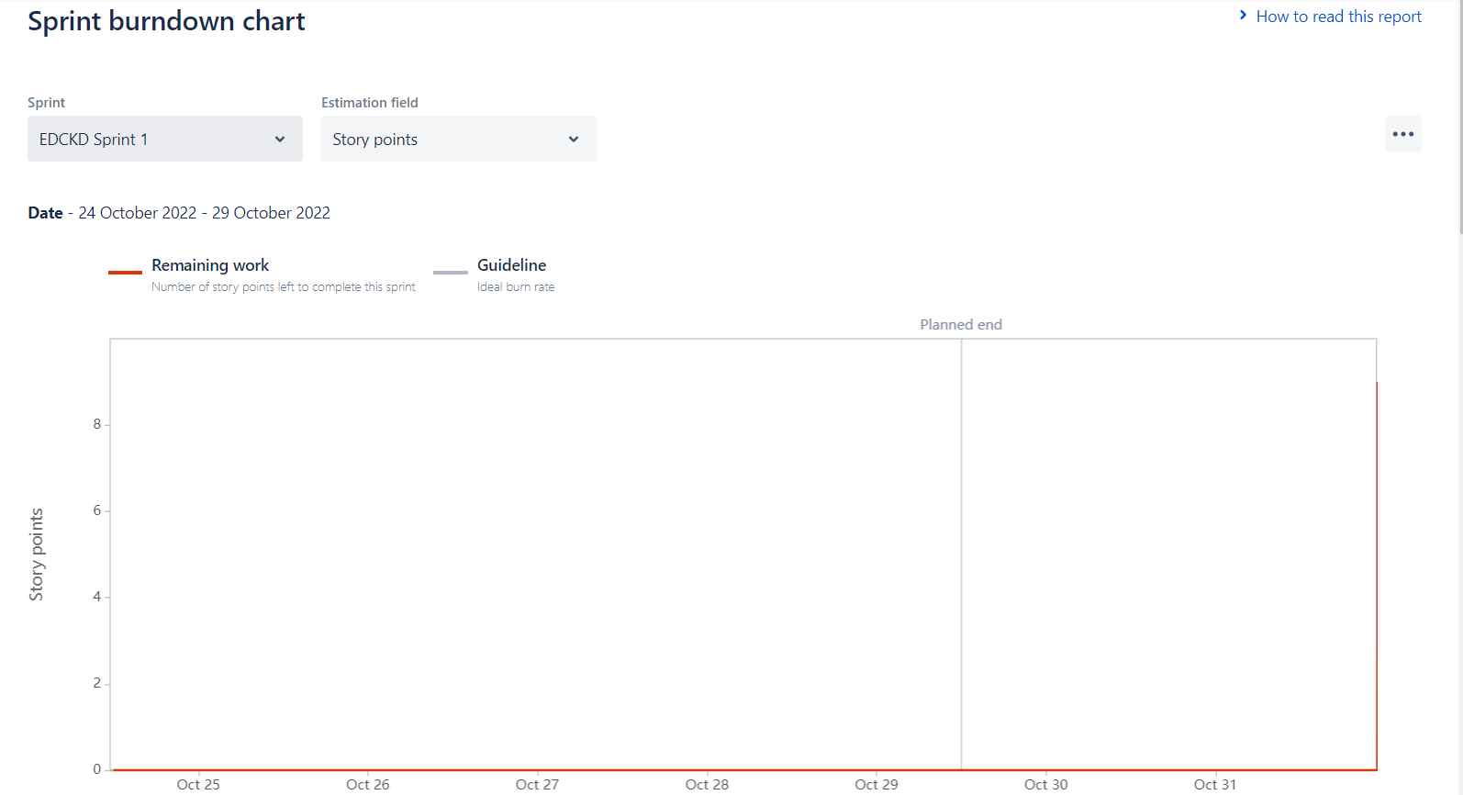

**Velocity Chart:**

